# CS 255 System Design Document Template

This template lays out all the different sections that you need to complete for Project Two. Each section has guidance to prompt your thinking. You will need to continually reference the interview transcript as you work to make sure that you are addressing your client’s needs. There is no required length for the final document. Instead the goal is to complete each section based on what your client’s needs are. Remove this note when you are finished, and replace all bracketed text with the relevant information.

## UML Diagrams

### UML Use Case Diagram

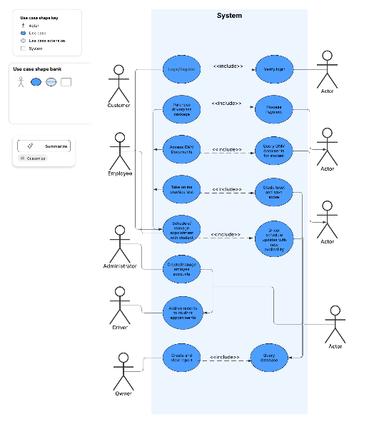

### UML Activity Diagrams

### UML Sequence Diagram

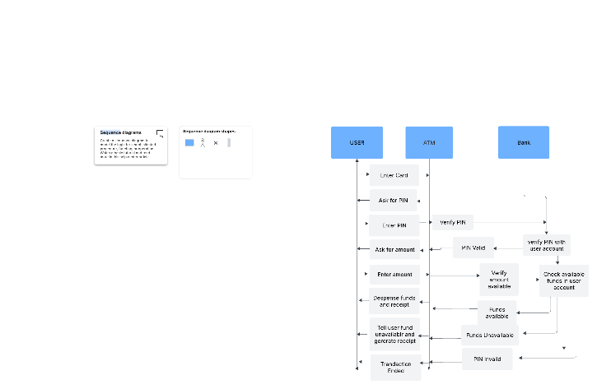

### UML Class Diagram

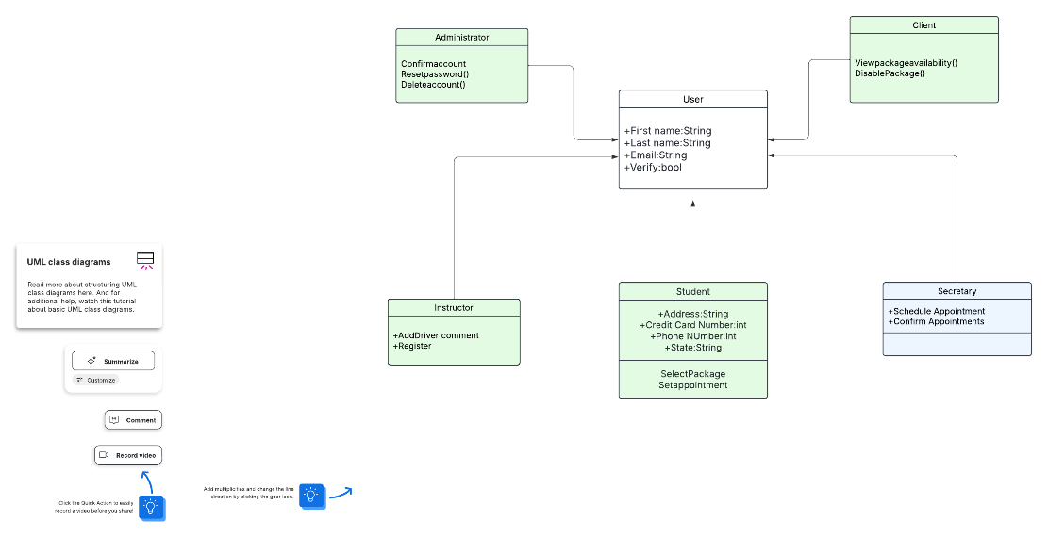

## Technical Requirements

With the diagrams I have created, there are a few technical requirements of my system. These include:

* Payment Validation: Ensure all payments are verified and processed securely.
* Request Validation: Authenticate and verify user-generated requests to maintain system integrity.
* User Permissions Management: Control access levels and enforce user-specific privileges.
* Package Deactivation: Provide functionality to disable or suspend user packages when needed.
* User Authentication: Handle login requests securely to verify user identities.
* Password Recovery: Support password reset requests to assist users in regaining account access.